
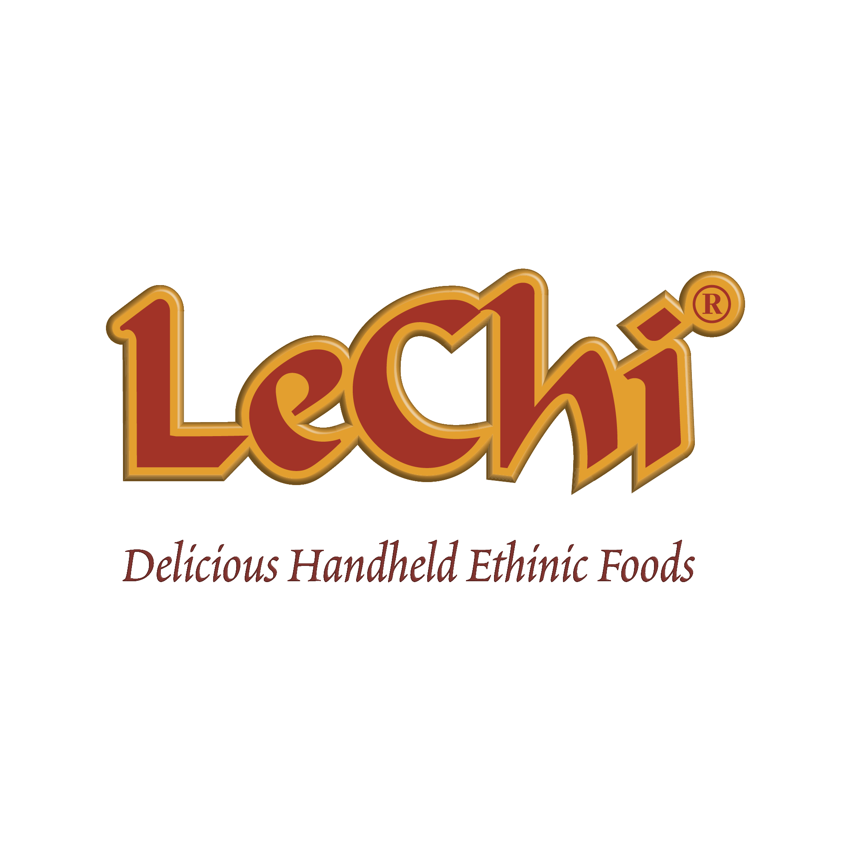
NUTRITION & ANALYSIS SHEET
Golden Valley Fundraising Kolache
Chicken & Beef with Cheese Sausage Baked in Roll
Product Code: 129(Golden Valley-Seitz)
Portion Size: 2 oz.
Packed: 20/4ct/case
Case Net Weight: 10 lbs. (4.53 kgs.)
Case Dimensions: Inner Carton - 8-5/8 X 5-1/2 X 5-3/8, M.Case - 18-1/2 X 12-9/16 X 5-3/4
Palletizing: 8 x 10 UPC: 26524 10826

Product Specifications:
LeChi’s 2oz. White Morning Kolache(Single Pack) is fully cooked and ready for heating (by oven or microwave) and serving. Each Kolache provides 1 oz. equivalent meat/meat alternate and 1 serving of Whole Grains.

Ingredients:
Dough: Bleached Enriched Wheat Flour ((NIACIN, REDUCED IRON, THIAMINE MONONITRATE, RIBOFLAVIN, FOLIC ACID), MALTED BARLEY FLOUR), Water, Sugar, Margarine (Palm Oil, Water, Soybean Oil, Salt, Contains 2% or Less of: Mono and Diglycerides, Annatto (Color), Calcium Disodium EDTA (Preservative), Artificial Flavor, Vitamin A Palmitate added.), Whey (Milk), Yeast (Saccharomyces Cerevisiae, Emulsifier (Sorbitan Monostearate, Antioxidant (Ascorbic Acid), Whole Eggs, Salt, Dough Conditioner (Enriched Wheat Flour (Wheat Flour, Niacin, Reduced Iron, Thiamine Mononitrate, Riboflavin, Folic Acid), Diacetyl Tartaric Acid Esters Of Mono-Diglycerides (DATEM), Contains Less Than 2% Of Soybean Oil, Ascorbic Acid (Vitamin C), Enzymes, L-Cysteine Hydrochloride)
Filling: Mechanically Separated Chicken, Water, Beef, Cheddar Cheese (Pasteurized Milk, Cheese Cultures, Salt, Enzymes, Annatto Color, Anti-caking Agent (Potato Starch Powder Cellulose, Natamycin)), Soy Protein Concentrate, Dextrose, Corn Syrup Solids, Flavorings (Ground Mustard, Chili Pepper Dark), Salt, White Pepper, Autolyzed Yeast, Sodium Phosphate, Granulated Garlic, Paprika, Sodium Erythobate, Sodium Nitirite.

Nutritional Analysis
Serving Size 1 piece (56g)
Serving Per Container: 20
Amount per Serving
Calories 129 Calories from Fat 25
% Dailey Value *
Total Fat 3g 4.3%
Saturated Fat 1g
Trans Fat 0 g
Cholesterol 21 mg 7%
Sodium 323 mg 13.5%
Total Carbohydrates 17g 6%
Dietary Fiber 1g 5%
Sugar 4g
Protein 7g
Vitamin A 107iu Vitamin C 2mg
Calcium 17mg Iron 3mg
% of Calories from Fat 20%
* Percent daily values are based on a 2,000 calories diet. Your daily values may be higher or lower depending on your calories needs.
PRODUCT ANALYSIS:
Descriptions: Chicken & Beef & Cheese Kolache
Product code: 10826(LeChi) / 129(GV-Seitz)
Pack/Portions: 4ct/20/2 oz.
Dough Weight: 1.0 oz.
Filling Weight: 1.0 oz.
Raw Product Weight: 2. oz.
Cooked Product Weight: 2. oz.
Protein Sources: Chicken, Beef, Cheese
Meat/Meat Alternate per Serving: 1 oz.
Whole Grains per Serving: 1 (16gr)

Shelf Life: 8 months frozen.

CONTAINS: Wheat, Milk, Egg, Soy

Microbiological Parameter | Acceptable Limit
APC (Aerobic Plate Count) | ≤ 100,000 CFU/gram
Yeast & Mold | ≤ 1,000 CFU/gram
Listeria | Negative / 25 grams
Salmonella | Negative / 25 grams

I certify that the above information is accurate as present on this date.

Name: Title:

Signature: Date:

